# Main Solution:

Going to the link provided, we can see that it seems to be a management console using RabbitMQ, the hint on the challenge stated that the default credentials should work, so proceeding with a google search we can see that RabbitMQ’s default credentials are guest:guest and there is also a likely default admin:changeme if they have yet to configure the RabbitMQ.

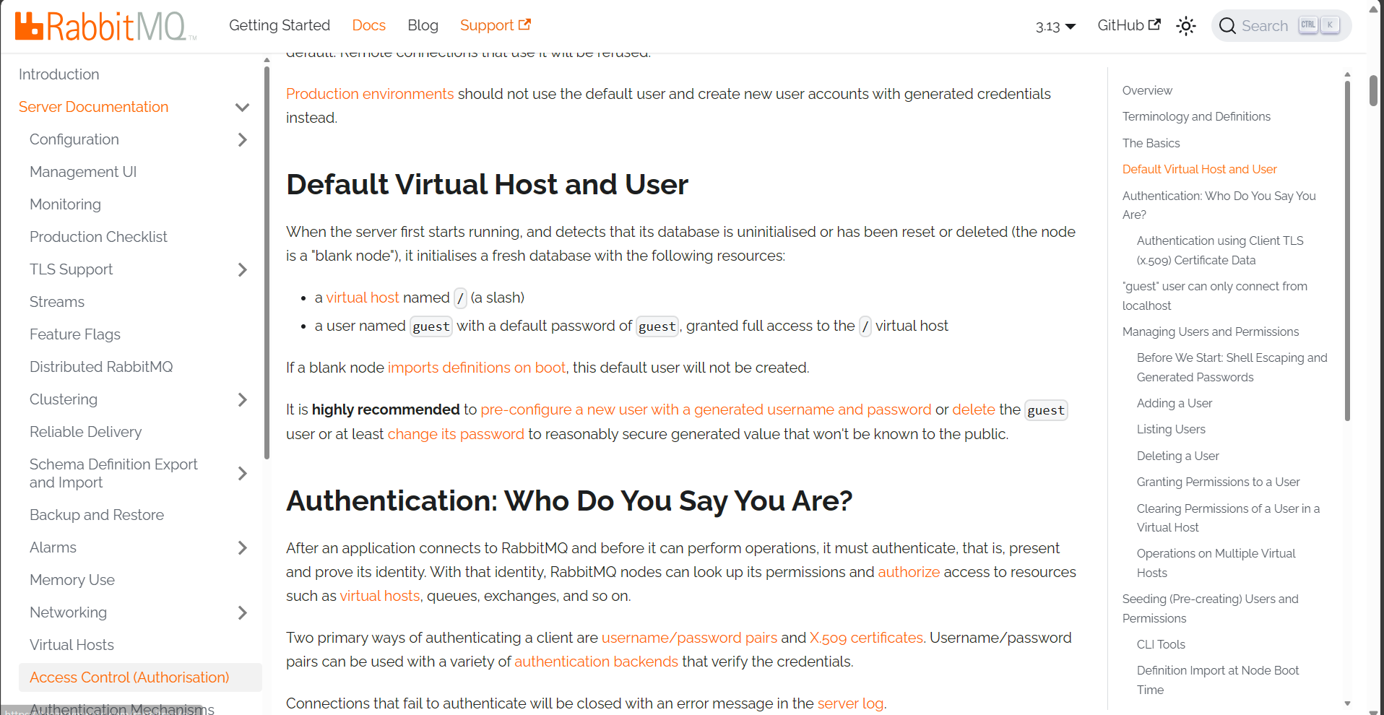

Source: <https://www.rabbitmq.com/docs/access-control>

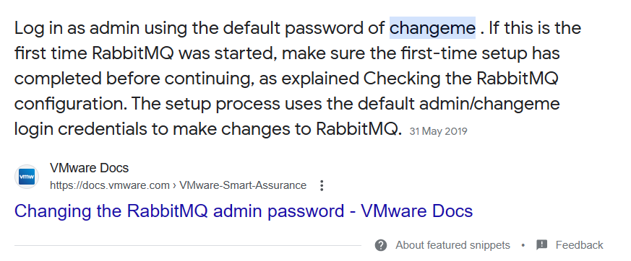

Source: <https://docs.vmware.com/en/VMware-Smart-Assurance/10.1.12/vsa-solutionpacks-articles-10112/GUID-1564E5A4-8321-4285-8532-87EFD439AF94.html#:~:text=Log%20in%20as%20admin%20using,to%20make%20changes%20to%20RabbitMQ>.

Trying both, we see that **guest:guest** was the password for the portal

Once inside, after navigating through all the tabs, we can see under queues, there were quite alot of messages, this could likely contain something interesting. Would skip documenting the irrelevant ones since there is nothing interesting there.

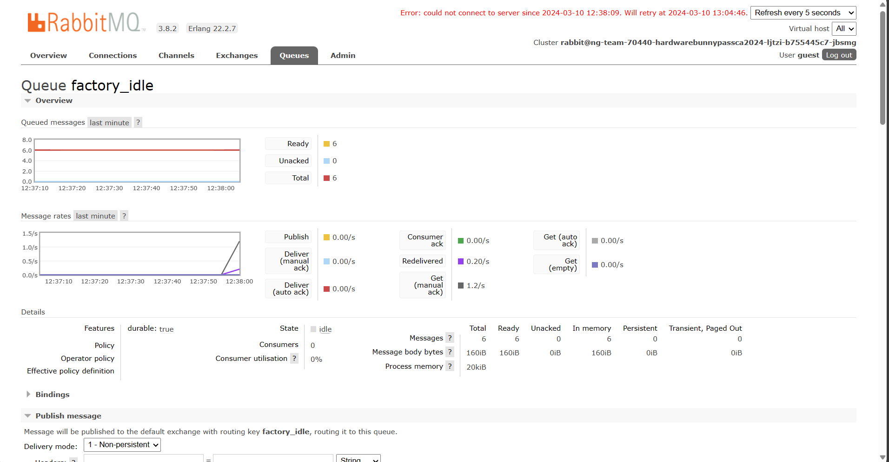

Under the queue factory_idle we see that there are 6 messages ready to be displayed, using the build in function to get messages, we can specify to get all 6 messages.

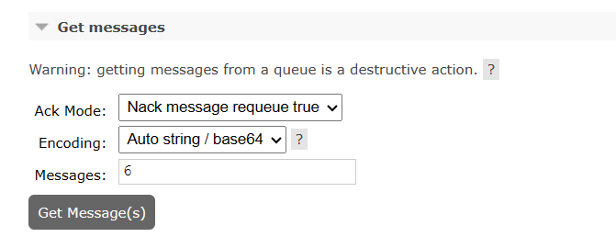

And the flag was found.

